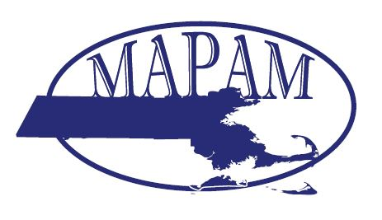
Notice of Meeting

Date: | Thursday, April 20, 2016
Place: | Best Western Royal Plaza  181 Boston Post Road W  Marlborough, MA 01752
Coordinators: | Becky Hilbig - Harrington Hospital  Sandra Magaw – ROI /Bolder Healthcare Solutions
Topic: | “Showering you with Best Practices!”  

Meeting Agenda
8:30 – 9:00 am | Registration and Breakfast
9:00 – 9:15 am | Updates and Announcements  Tim Moore, MAPAM President
9:15 – 10:00 am | Best Practices for Worker’s Compensation and Auto Claims  Maureen Dukett, Client Service Manager, Parallon
10:00 – 11:00 am | Modifier Madness!  Julie Hall and Jon Menard, Consultants, ROI
11:00 – 11:15 am | Networking and Break
11:15 – 12:15 PM | Get More, Spend Less: Vendor Management Best Practices  Nicholas Fricano, President and CEO, Healthfuse
 | Questions
2

Deadline for Submission: April 13, 2017
Member Price: $60.00
Nonmember Price: $100.00
Registrations are required to be submitted on line at WWW.MAPAM.ORG for both members and non-members with an option to pay on line or receive a printable version to submit to your Accounts Payable Department. As you go through the payment screens you will be offered the option of paying by credit card or check. Once you select pay by check, an invoice will be e-mailed to you immediately.
Dress is Business Casual

